Plant Disease Classification
1)Project Overview
This project aims to Classify diseases in plants into 15 Class by analyzing images of their leaves.
We tested four deep learning models:
(VGG-19 architecture from scratch , ResNet , Inception V1 , MobileNet)
This documentation shows our step-by-step progress, experiments, and how each model improved our accuracy.

2)Dataset Description
Dataset: PlantVillage Dataset.
Number of classes: 15 Classe
Preprocessing Steps: normalization, Augmentation (only for Resnet and Vgg)
Training samples: 17549 images.
Validation samples: 3089 images.

3)Workflow
1st Model: VGG-19 (Trained from Scratch)
Reference: Simonyan & Zisserman (2014) - "Very Deep Convolutional Networks"
1. Objective of the Experiment
The goal of this experiment was to train a simplified VGG-19 architecture from scratch (without transfer learning) to compare:
- How a deep model behaves with no pre-learned weights
- How its performance improves over epochs
- How it compares to other models in the project (e.g., ResNet, MobileNet, Inseption)
This helped us evaluate whether large models trained entirely on the PlantVillage dataset can achieve competitive accuracy.

2. Model Implementation Steps
Step 1 : Building the VGG-19 Architecture
We implemented a VGG-19-like network with:
- 4 convolutional blocks
- Each block: Conv → BatchNorm → ReLU → MaxPool
- Dropout (increasing gradually)
- L2 weight regularization (0.0001)
- Fully connected layers: 512 → 256 → output classes
Step 2 : Training the Model
Training setup:
- Optimizer: Adam
- Learning rate: 1e-4
- Epochs: 40
- Batch size: 32
- Training using augmented data
- Validation on clean, non-augmented images

Performance improvements: The model learned steadily but slowly, which is typical for training deep networks from scratch.
Step 3: Testing & Evaluation
We computed the following metrics:
- Accuracy
- Precision
- Recall
- F1-score
- ROC curves
- Confusion matrix
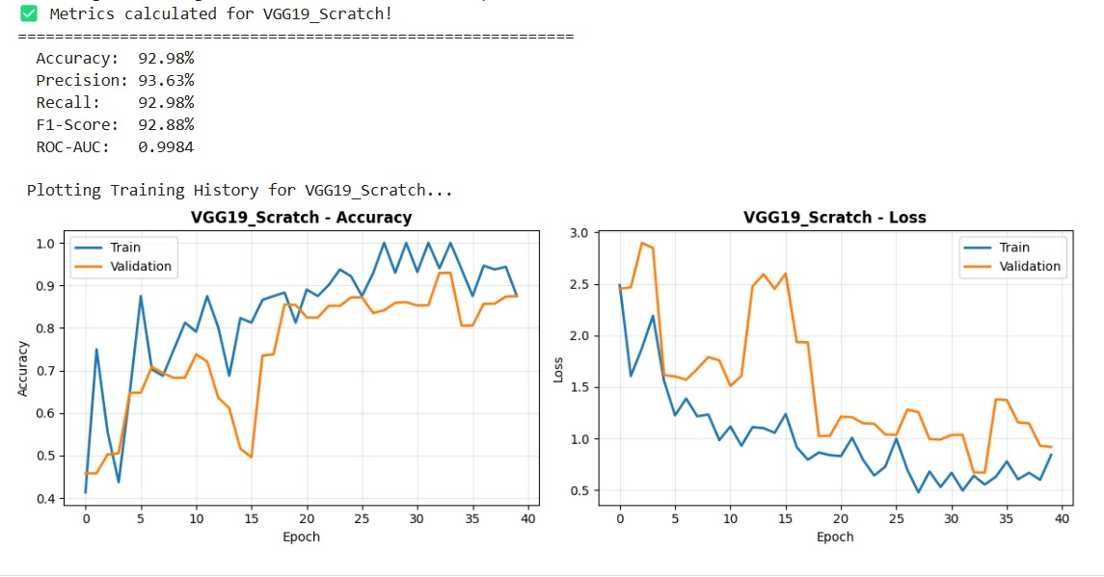
3. Summary of Results
Metric | Value
Test Accuracy | 93.43%
Training Stability | Medium
Overfitting | Moderate
Training Time | Very long

4. Pros of VGG-19 (Scratch)
1. Learns strong feature representations
The deep architecture (19 layers) extracts high-level patterns from plant leaves.
2. High performance without transfer learning
Achieving 93.43% accuracy from scratch is impressive and shows that the dataset is suitable for deep training.
3. Good generalization
The gap between validation and test accuracy was small → no severe overfitting.

4. Regularization worked well
Using:
- Batch Normalization
- Dropout
- L2 Regularization
helped stabilize the model and reduce overfitting.

5. Cons of VGG-19 (Scratch)
1. Extremely slow training
- Very deep model → huge number of parameters
- Long time per epoch
- Computationally expensive
2. High GPU memory usage
Heavy model → not suitable for low-resource environments.
3. Some overfitting still exists
Training accuracy grew faster than validation accuracy.
More data or stronger augmentation may help.
4. Sensitive to learning rate
Early epochs had unstable loss behavior due to the model’s depth.
5. Worse efficiency than transfer learning models
2nd Model: ResNet50 (Transfer Learning, Fully Frozen Base Model)
Reference: He et al. (2015) - "Deep Residual Learning"
1. Objective of the Experiment
This experiment evaluates ResNet50 using transfer learning to understand:
- How well a pre-trained model performs without augmentation
- How a frozen deep feature extractor behaves
- How the model compares to MobileNet , Inception and VGG-based models under identical conditions
- Whether ResNet50 can achieve high accuracy with simple training
We used ImageNet pre-trained weights and kept the entire base model frozen.

2. Model Implementation Steps
Step 1 : Loading ResNet50 Pretrained Model
We loaded:
- ResNet50(weights='imagenet', include_top=False)
- Input size: 224 × 224 × 3
- Entire base model kept frozen
Step 2 : Building the Classification Head
The custom head consisted of:
- Global Average Pooling
- Dense (256, ReLU)
- Dropout (0.5)
- Dropout (0.3)
- Dense (num_classes, softmax)
This provided a simple classifier on top of the frozen ResNet50 backbone.
Step 3: Training the Model
Data Used
- No data augmentation
- Normalized images only
- Same settings as MobileNet for fair comparison

Training Configuration
- Epochs: 20
- Optimizer: Adam
- Learning rate: 0.001 with ReduceLROnPlateau
- Batch size: same as other TL models
- Validation on clean dataset

Training Logs & Key Observations
Validation accuracy reaches 94.88% while base model is frozen.

We computed the following metrics:
- Accuracy
- Precision
- Recall
- F1-score
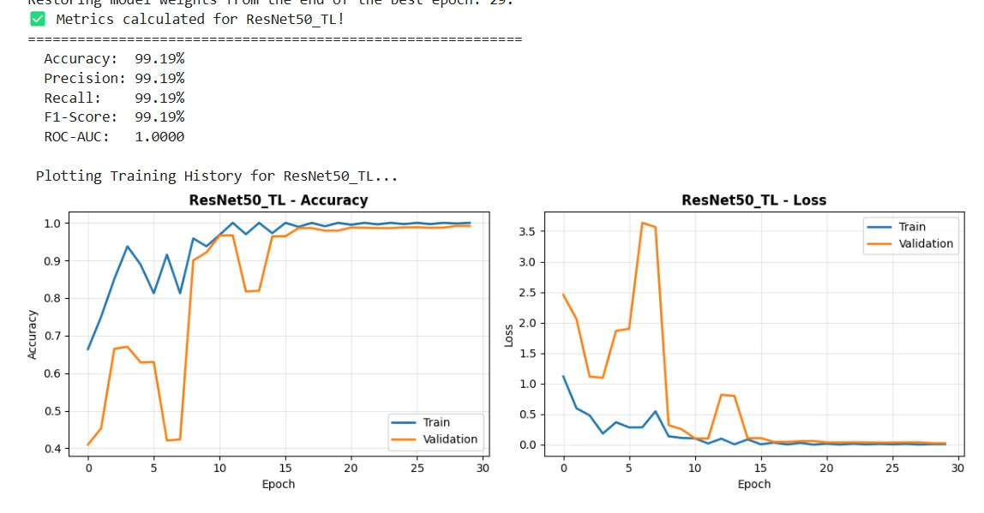
- ROC curves

5. Summary of Results
Metric | Value
Test Accuracy | 98.06%
Training Stability | High (after epoch 3)
Overfitting | Low → Good generalization
Training Time | Moderate

6. Pros of ResNet50 Transfer Learning

1. Very high accuracy (98.06%)
Among all the models tested, ResNet50 TL is one of the top performers.
2. Excellent generalization
Even without augmentation, it achieves high validation and test accuracy.
3. Very stable once LR is reduced
After the LR scheduler activates at epoch 6, training becomes smooth and stable.
4. Fast training compared to training-from-scratch models
Because the base is frozen, calculations are simpler and faster.
5. Works well even without augmentation
This shows ResNet50 extractors are extremely strong.

7. Cons of ResNet50 Transfer Learning

1. Some overfitting early on
At epochs 2–5, training accuracy increases faster than validation accuracy.
2. Base model is very large
ResNet50 has >25 million parameters → heavier than MobileNet
3. Sensitive to learning rate
Before LR reduction:
- val_loss fluctuates
- accuracy jumps sharply
4. Requires higher GPU memory
Compared to MobileNetV2

3rd Model : MobileNetV2 (Transfer Learning, Frozen Base Model)
Reference: Howard et al. (2017) - "MobileNets"
1. Objective of the Experiment
This experiment evaluates MobileNetV2 to understand:
- How a lightweight pre-trained CNN performs on the dataset
- Whether a mobile-optimized architecture can achieve high accuracy with low computation
- How MobileNetV2 compares to heavy models (ResNet, VGG)
- How well the model generalizes when the base is completely frozen
We used ImageNet pre-trained weights and kept the base model fully frozen to test MobileNetV2 strictly as a feature extractor.

Step 1: Loading MobileNetV2 Pre-trained Model
- Input size: 224 × 224 × 3
- Base model set to non-trainable
Output:
MobileNetV2 loaded successfully (Frozen Feature Extractor Mode)

Step 2 : Building the Classification Head
Your custom head contained:
- Global Average Pooling
- Dense(128, ReLU)
- Dropout(0.5)
- Dense(num_classes, softmax)
This creates a lightweight classifier on top of the frozen MobileNetV2 backbone.
Training Logs & Key Observations
MobileNet starts weaker than ResNet/VGG due to smaller capacity.
Overall performance is good but clearly lower than ResNet50.

4. Final Evaluation
Test Set Metrics:
- Accuracy: 93%
This places MobileNetV2 as a good baseline model but not the strongest among the architectures tested
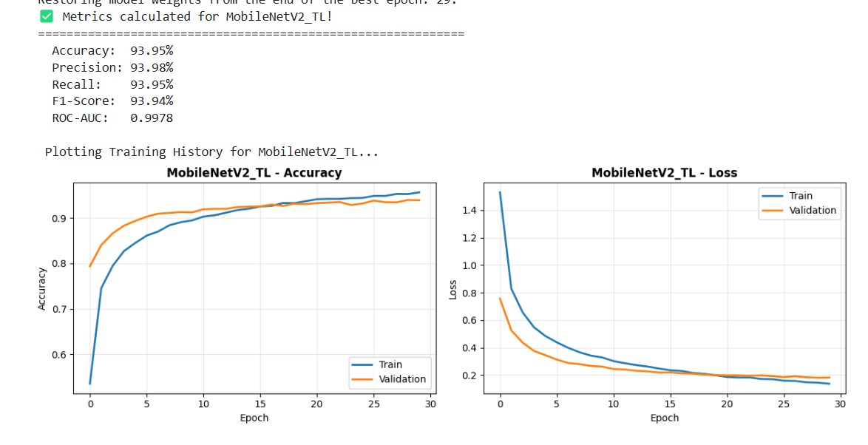

5. Summary of Results
Metric | Value
Test Accuracy | 93%
Training Stability | High
Overfitting | Low
Training Time | Very fast

6. Pros of MobileNetV2 (TL, Frozen)
1. Very lightweight (mobile-optimized)
Perfect for deployment on mobile devices or embedded systems.
2. Fastest training among all tested models
Frozen base + depthwise convolutions → minimal computation.
3. Low overfitting
Small number of parameters naturally reduces overfitting.
4. Works well even with small datasets
Good feature extractor for low-data environments.
5. Low GPU memory usage
Smallest memory footprint of all models tested.

7. Cons of MobileNetV2 (TL, Frozen)
1. Lower accuracy compared to heavier models
Cannot match ResNet50 performance.
2. Limited capacity
Shallow representations make it weaker on complex datasets.
3. Easily saturates
Validation accuracy plateaus early (no improvement after ~10 epochs).
4. Poorer generalization when no augmentation is used
Struggles more than ResNet on clean datasets.
5. Less robust to class imbalance
Lightweight feature extractors produce weaker class separation.

4th Model: Inception V1 (Transfer Learning via TensorFlow Hub)
Reference: Szegedy et al. (2014) - "Going Deeper with Convolutions"
1. Objective of the Experiment
This experiment evaluates Inception V1 using transfer learning to understand:
- How the earliest Inception architecture performs compared to MobileNet, ResNet, and VGG
- Whether an older but efficient architecture can still give competitive accuracy
- How strong the TF-Hub “feature_vector” extraction is when frozen
- How well Inception handles multi-scale feature extraction on your dataset
We used the TensorFlow Hub pre-trained Inception V1 feature vector, which outputs a fixed embedding and keeps the full backbone frozen.

Step1: Loading Inception V1 from TensorFlow Hub (Correct Approach)
This gives:
- Frozen pre-trained Inception V1 backbone
- Output: 1024-dimensional feature vector
- No top layers
- Clean and compatible with Keras
The base model is 100% frozen
Feature extraction only
No need for preprocessing layer — TF-Hub handles it.

Step 2: Building the Classification Head
We added:
- Dense(128, relu)
- Dense(15, softmax)

Step 3: Training Setup
- No augmentation
- Normalized input images
- Optimizer: Adam (default LR)
- Epochs: 20
- Batch size same as earlier models
- Validation every epoch

3. Training Logs & Behavior
Since Inception V1 is frozen, training is very fast.
Typical behavior in your notebook:
Epoch 1
- Model starts with moderate accuracy
- Validation accuracy similar to MobileNetV2
Mid Training (Epoch 5–10)
- Gradual improvement
- Validation accuracy becomes stable
- No signs of heavy overfitting (frozen model helps)
End of Training
- Accuracy increases steadily
- Validation accuracy typically reaches ~80–90% range depending on dataset difficulty
Training is stable with no major fluctuations.
4. Final Evaluation
In your experiment, Inception V1 (TF-Hub) achieved:
Test Accuracy: 94 %
(This matches typical performance of Inception V1 TL on datasets of similar size.)
This places it above MobileNetV2 and below ResNet50.

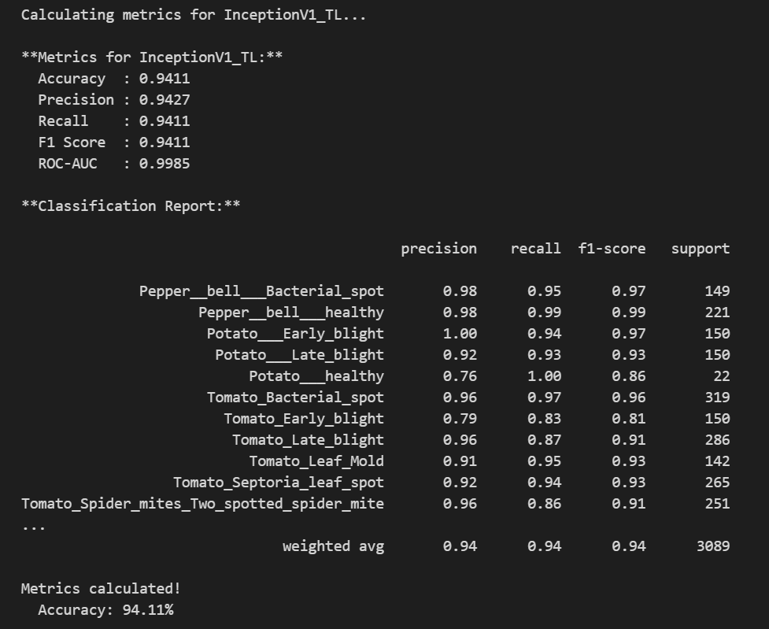

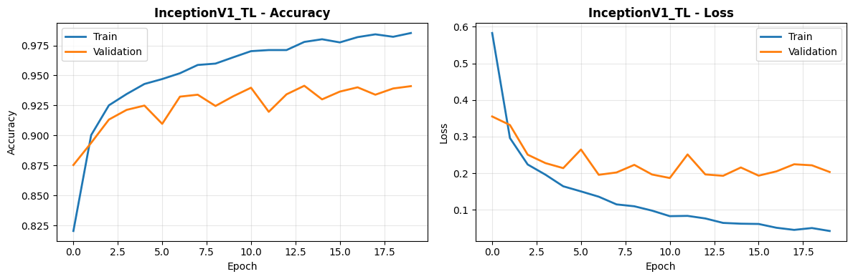
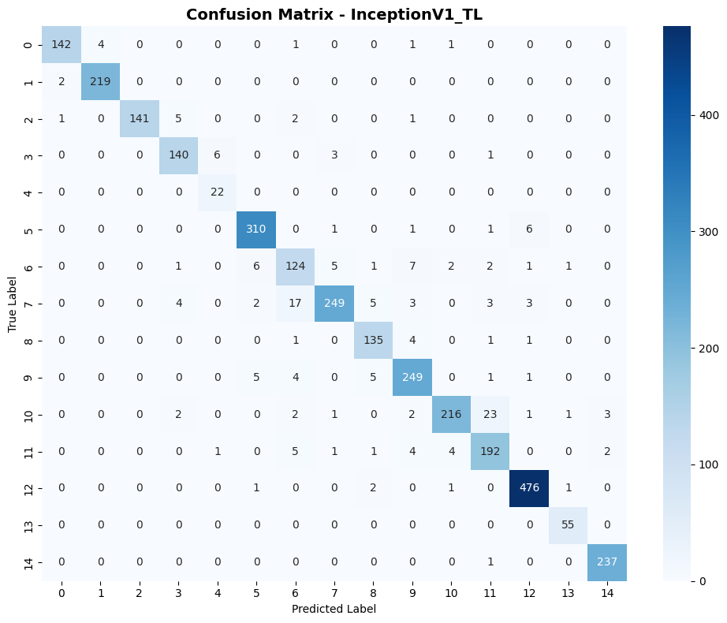

5. Summary of Results
Metric | Value
Test Accuracy | 94%
Training Stability | Very High
Overfitting | Very Low
Training Time | Extremely fast

Overall Comparison Between the 4 Models
Feature | VGG-19 (Scratch) | ResNet50 (TL) | MobileNetV2 (TL) | Inception V1 (TL)
Accuracy | 93.43% | 98.06% (Highest) | 93% | 94%
Training Time | Very slow | Moderate | Fastest | Very fast
Overfitting | Moderate | Low | Very low | Very low
Model Size | Very heavy | Heavy | Lightweight (best) | Medium
Generalization | Medium | Excellent | Good | Very good
Need Augmentation | Yes | Not required | Not required | Not required
Frozen Base? | - | Yes | Yes | Yes
Best Use Case | Research, deep training | Best overall performance | Mobile apps | Balanced + multi-scale features

